# WEEK6 Assignments

The Assignment given :

1. Configure Self-hosted integration runtime to Extract the data from your local server and load it into azure DB
2. Configure FTP/ SFTP server and create a ADF pipeline for data extraction
3. Create Incremental load pipeline and automate this on daily basis
4. Automate a pipeline to trigger every last Saturday of the month
5. Retrieving data. Wait a few seconds and try to cut or copy again.

Now to do all task should have knowledge about Azure DB and ADF pipeline configuration , so just surf internet and go all through this , absolutely we will have more than enough information.  
  
Lets go through all windows ….

# 1.

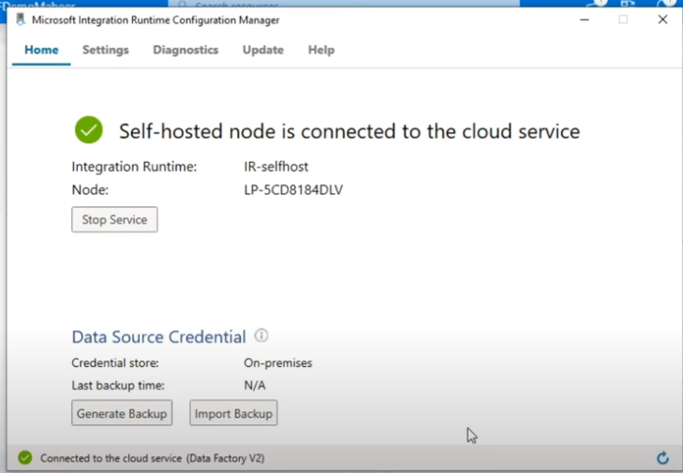

# 2

{

"name": "SftpLinkedService",

"type": "Sftp",

"properties": {

"typeProperties": {

"host": "your-sftp-server-address",

"port": 22,

"userName": "your-username",

"password": {

"type": "SecureString",

"value": "your-password"

}

}

}

}

# 3.

4.